Student Name: __________________________________
5th Grade Weekly Homework

Week of: ______________________________
 |  | Homework  Completed | 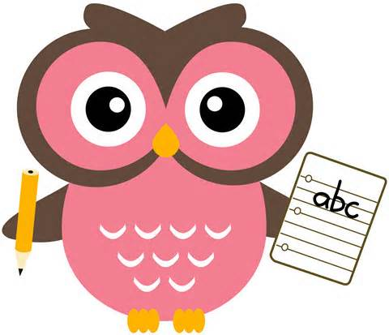  Language Arts | Homework Completed
Monday  / |  | ____ INC.  ____ NO |  | ____ INC.  ____ NO
Tuesday  / |  | ____ INC.  ____ NO |  | ____ INC.  ____ NO
Wednesday  / |  | ____ INC.  ____ NO |  | ____ INC.  ____ NO
Thursday  / |  | ____ INC.  ____ NO |  | ____ INC.  ____ NO
Reminders:

Daily Behavior/Clip Changes

Key:  ★= Great  1= Verbal Warning  2= 10 Min. Away  3= Lunch Duty  4= Letter Home  5= Office (Privilege Lost) | Monday  ★  1 2 3 4 | Tuesday  ★  1 2 3 4 | Wednesday  ★  1 2 3 4
 | Thursday  ★  1 2 3 4 | Friday  ★  1 2 3 4 | Parent  Signature: _________________

